Hafiz Ahmad

19l-1316

Introduction to computing lab:

Lab Report No 3:

**Introduction to Visual Studio 2012 and C++ Basics:**

**OBJECTIVE:**

• To be able to use Visual Studio for compiling simple C++ Programs.

• To be able to understand I/O environment in C++

• To get familiar with data types

• To be able to understand and solve a programming problem using C++ arithmetic expressions.

**Microsoft Visual Studio tutorial:**

**Q no 1:**

#include <iostream>

using namespace std;

int main()

////{

//// cout<<"hello world\n";

////}

Q no 1:

////{

//// cout<<"************************************************************\n";

//// cout<<"Hafiz Ahmad\t"<<"19L-1316\t"<<"electrical enggenering\t"<<"2nd\n";

//// cout<<"************************************************************\n";

////}

Q no 2:

////{

//// int a,b,c;

//// a=1;

//// b=2;

//// c=3;

//// cout<<"a\t"<<"b\t"<<"c\n";

//// cout<<a*2<<"\t"<<b*2<<"\t"<<c*2<<"\n";

//// cout<<a+3<<"\t"<<b+2<<"\t"<<c+2<<"\n";

////}

Qno 3:

////{

//// cout<<"\t *\n";

//// cout<<"\t **\n";

//// cout<<"\t ***\n";

//// cout<<"\t ****\n";

////}

Q no 4:

{

int a,b,c,d,e,f,g,h,i,j,k,l,m,n,o;

a=1;

b=a+1;

c=b+1;

d=c+1;

e=d+1;

f=e+1;

g=f+1;

h=g+1;

i=h+1;

j=i+1;

k=j+1;

l=k+1;

m=l+1;

n=m+1;

o=n+1;

cout<<a<<"\t"<<a*a<<"\t"<<a*a*a<<"\n";

cout<<b<<"\t"<<b*b<<"\t"<<b*b*b<<"\n";

cout<<c<<"\t"<<c*c<<"\t"<<c*c*c<<"\n";

cout<<d<<"\t"<<d*d<<"\t"<<d*d*d<<"\n";

cout<<e<<"\t"<<e*e<<"\t"<<e*e*e<<"\n";

cout<<f<<"\t"<<f*f<<"\t"<<f*f*f<<"\n";

cout<<g<<"\t"<<g*g<<"\t"<<g*g*g<<"\n";

cout<<h<<"\t"<<h*h<<"\t"<<h*h*h<<"\n";

cout<<i<<"\t"<<i*i<<"\t"<<i*i*i<<"\n";

cout<<j<<"\t"<<j*j<<"\t"<<j*j*j<<"\n";

cout<<k<<"\t"<<k*k<<"\t"<<k*k*k<<"\n";

cout<<l<<"\t"<<l*l<<"\t"<<l*l*l<<"\n";

cout<<m<<"\t"<<m*m<<"\t"<<m*m*m<<"\n";

cout<<n<<"\t"<<n*n<<"\t"<<n*n*n<<"\n";

cout<<o<<"\t"<<o*o<<"\t"<<o*o*o<<"\n";

}

Post Lab:

Q no 1:

#include <iostream>

using namespace std;

int main()

{

cout<< "\t--------------/////---------------------\n";

cout<< "\t| R |\n";

cout<< "\t| |\n";

cout<<"\t(V) ---\n";

cout<< "\t| C \n";

cout<< "\t| ---\n";

cout<< "\t| |\n";

cout<< "\t| |\n";

cout<< "\t----------------------------------------\n";

}

Q no 2

{

float V;

float R;

float v;

float P;

cout<<"enter the voltage:"<<endl;

cin>>V;

cout<<"enter the resistace:"<<endl;

cin>>R;

v=V*V;

P=v/R;

cout<<"Power:"<<P<<endl;

}

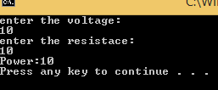

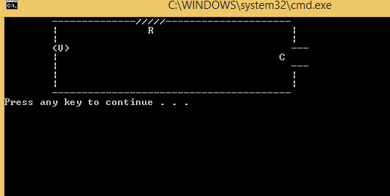

**Conclusion:**

I this lab we learn bascis of programming and how cout and cin from user.